O2-A6A – Guidelines for Leadership Schools: Annex
Leadership development for leaders of digital transformation in higher education in Europe: Appendices
Paul D. BACSICH
Sero Consulting Ltd, for D-TRANSFORM

Guidelines for Leadership Schools: Annex
Contents
Appendix 1 – Programme of Leadership School 1 3
Appendix 2 – Programme of Leadership School 2 7
Appendix 3 – Programme of MOOC 10
Appendix 4 – Project Outputs of most relevance to Leaders 11
A4.1 Public Digital Policies in Higher Education – A comparative survey between Spain, France, Italy and the United Kingdom 11
A4.2 Business models for opening up education – Sustainability of MOOCs, OER and related online education approaches in higher education in Europe 11
A4.3 Open Educational Resource, a lever for digital transition of higher education? 12
A4.4 Guidelines for governance of HE institutions 12
Appendix 5 D-TRANSFORM MOOC: Data snapshot 13

Appendix 1 – Programme of Leadership School 1
This took place in Barcelona, 14-18 November 2016. The delegates are pictured below.
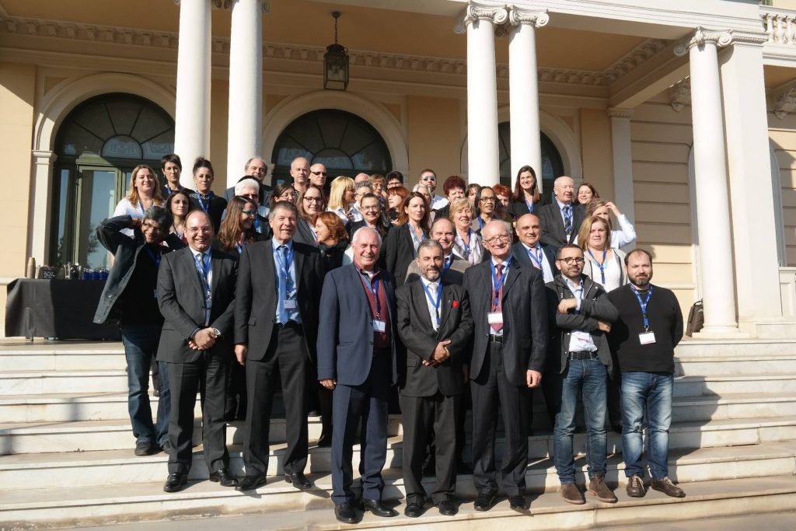
The programme given below is adapted from the one on the web at http://symposium.uoc.edu/event_detail/5855/programme/1st-dtransform-digital-leadership-school.html

Monday 14 November 2016
- 14:00 – 14:15
Welcome and announcements
Welcome: Josep A. Planell (UOC President)
Introduction: Marta Aymerich (UOC Vice-president)
- 14:15 – 14:30
Elevator introductions of participants
Marta Aymerich (UOC Vice-president)
- 14:30 – 15:30
Opening Keynote
The opening up of education and the modernisation of higher education agenda in Europe
Keynote Speaker: Andreia Inamorato dos Santos (IS Unit, European Commission)
Moderator: Marta Aymerich (UOC Vice-president)
- 15:30 – 16:00
Refreshment break
- 16:00 – 18:00
Working Session
Millennials and strategies (profile, content consumers and cyberculture)
Speakers: Ismael Peña (UOC), Steve Wheeler (Plymouth University), Elena Neira (Marketing, Social Networks and Technology Consultant)
- 18:00 – 18:30
End of session
- 18:30 – 19:00
Cocktail Reception

Tuesday 15 November 2016
- 09:00 – 09:15
Newcomer introductions
Paul Bacsich (SERO Consulting)
- 09:15 – 11:00
Working Session
Digital libraries and digitally enabled study spaces: more than just a librarian’s issue?
Speakers: Ciro Lluerca (UOC) and Rosie Jones (UKOU)
Moderator: Núria Ferran (UOC)
- 11:00 – 11:30
Refreshment break
- 11:30 – 13:00
Working Session
Overcoming academic resistance to ICT-based teaching
Speakers: Roumiana Peytcheva-Forsyth (Sofia University) and András Benedek (Budapest University of Technology and Economics)
Moderator: Florence Ducreau (AUNEGE)
- 13:00 – 14:00
Lunch
- 14:00 – 15:00
Keynote
The Promise and the Reality of Analytics
Keynote speaker: Anne Boyer (UL)
Moderator: Paul Bacsich (SERO Consulting)
- 15:00 – 15:15
Refreshment break
- 15:15 – 17:00
Working Session
Learning analytics: Ready now to serve institutional needs?
Speakers: Jordi Conesa (UOC), Julià Minguillón (UOC), Azim Roussanaly (UL), Mark Nichols (UKOU)
Moderator: Paul Bacsich (SERO Consulting)
- 17:00 – 17:30
End of session

Wednesday 16 November 2016
- 08:00 – 09:00
Shuttle to UOC headquarters (Tibidabo)
- 09:00 – 09:15
Newcomer introductions
Susanna Sancassani (Politecnico di Milano – METID)
- 09:15 – 11:00
Working Session
New approaches to assessment
Speakers: Ana Elena Guerrero (UOC), Andrea Karpati (ELTE University), Albert Sangrà (UOC)
Moderator: Carles Sigalés (UOC Vice-president)
- 11:00 – 11:30
Refreshment break
- 11:30 – 13:00
Working Session
Benchmarking digital institutions
Speakers: Paul Bacsich (SERO Consulting), António Teixeira (Universidade Aberta and former EDEN president)
- 13:00 – 14:00
Lunch
- 14:00 – 15:00
Keynote
What can we learn from small innovative online HE providers?
Speakers: Michael Stewart (The Interactive Design Institute), Jordi Llonch (Sharing Academy)
Moderator: Susanna Sancassani (Politecnico di Milano – METID)
- 15:00 – 15:30
End of session
- 16:00 – 18:00
Social Activity: Barcelona Tour
Departure from Tibidabo’s headquarters, visit to Sagrada Familia and arrival to the Silken Diagonal Hotel
- 19:30 – 22:30
Social Dinner
Museu Nacional d’Art de Catalunya (MNAC) – fee required
(Shuttle from Silken Diagonal Hotel)

Thursday 17 November 2016
- 09:00 – 09:15
Newcomer introductions
András Szücs (EDEN)
- 09:15 – 11:00
Keynote
Universities disrupted
Speaker: Vijay Kumar (MIT)
Moderator: Josep A. Planell (UOC President)
Open Discussion
- 11:00 – 11:30
Refreshment break
- 11:30 – 13:00
Keynote
European universities disrupted
Speaker: Ryan Craig (University Ventures)
Moderator: Josep A. Planell (UOC President)
Open Discussion
- 13:00 – 14:00
Lunch
- 14:00 – 15:30
Coffee-talk:
Making strategy for universities in the 21st century: the new game before the game
Speaker: Jean-Philippe Denis (Université Paris Sud / Saclay)
- 15:30 – 16:30
Working Session
The MOOCs panel
Speakers: Anne Boyer (UL), Manel Jiménez (UPF), Hannes Klöpper (Iversity)
Moderators: Ada Giannatelli (Politecnico di Milano – METID) and Denés Zarka (BME)
- 16:30 – 18:00
Working Session
Business models for opening up education
Speakers: Rajay Naik (Keypath), Paul Bacsich (SERO Consulting), Susanna Sancassani (Politecnico di Milano – METID)
Moderators: Teresa Sancho (UOC) and András Szücs (EDEN)
- 18:00 – 18:30
End of session

Friday 18 November 2016
- 09:00 – 09:15
Newcomer introductions
Denés Zarka (BME)
- 09:15 – 11:00
Working Session
Strategies for HE in the national context
Speaker: Susanna Sancassani (Politecnico di Milano – METID)
- 11:00 – 11:30
Refreshment break
- 11:30 – 12:30
Keynote
RRI in the strategy for the HE digital transformation
Speaker: Ignasi López-Verdeguer (RRI Tools – La Caixa Foundation)
Moderator: Pastora Martínez Samper (UOC Vice-president)
- 12:30 – 13:00
Keynote
Strategies for HE digital transformation
Speaker: François Taddei (Center for Research and Interdisciplinarity)
- 13:00 – 13:30
Closing the 1st Leadership School
Speakers: Françoise Thibault (FMSH vice-president) and Marta Aymerich (UOC Vice-president)
- 13:30 – 15:00
Buffet lunch
- 15:00 – 15:15
End

Appendix 2 – Programme of Leadership School 2
This was a five-day event which took place in France on 19-23 May in Nancy – including over the weekend. Some of the delegates can be seen below relaxing in Place Stanislas.
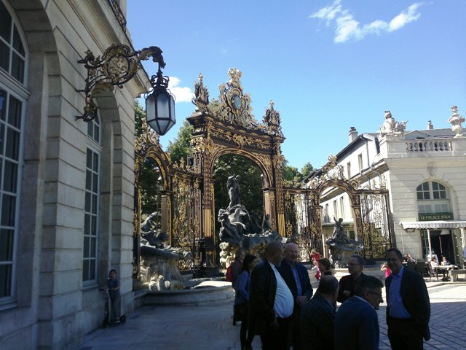

The programme is on the next two pages (in landscape format).

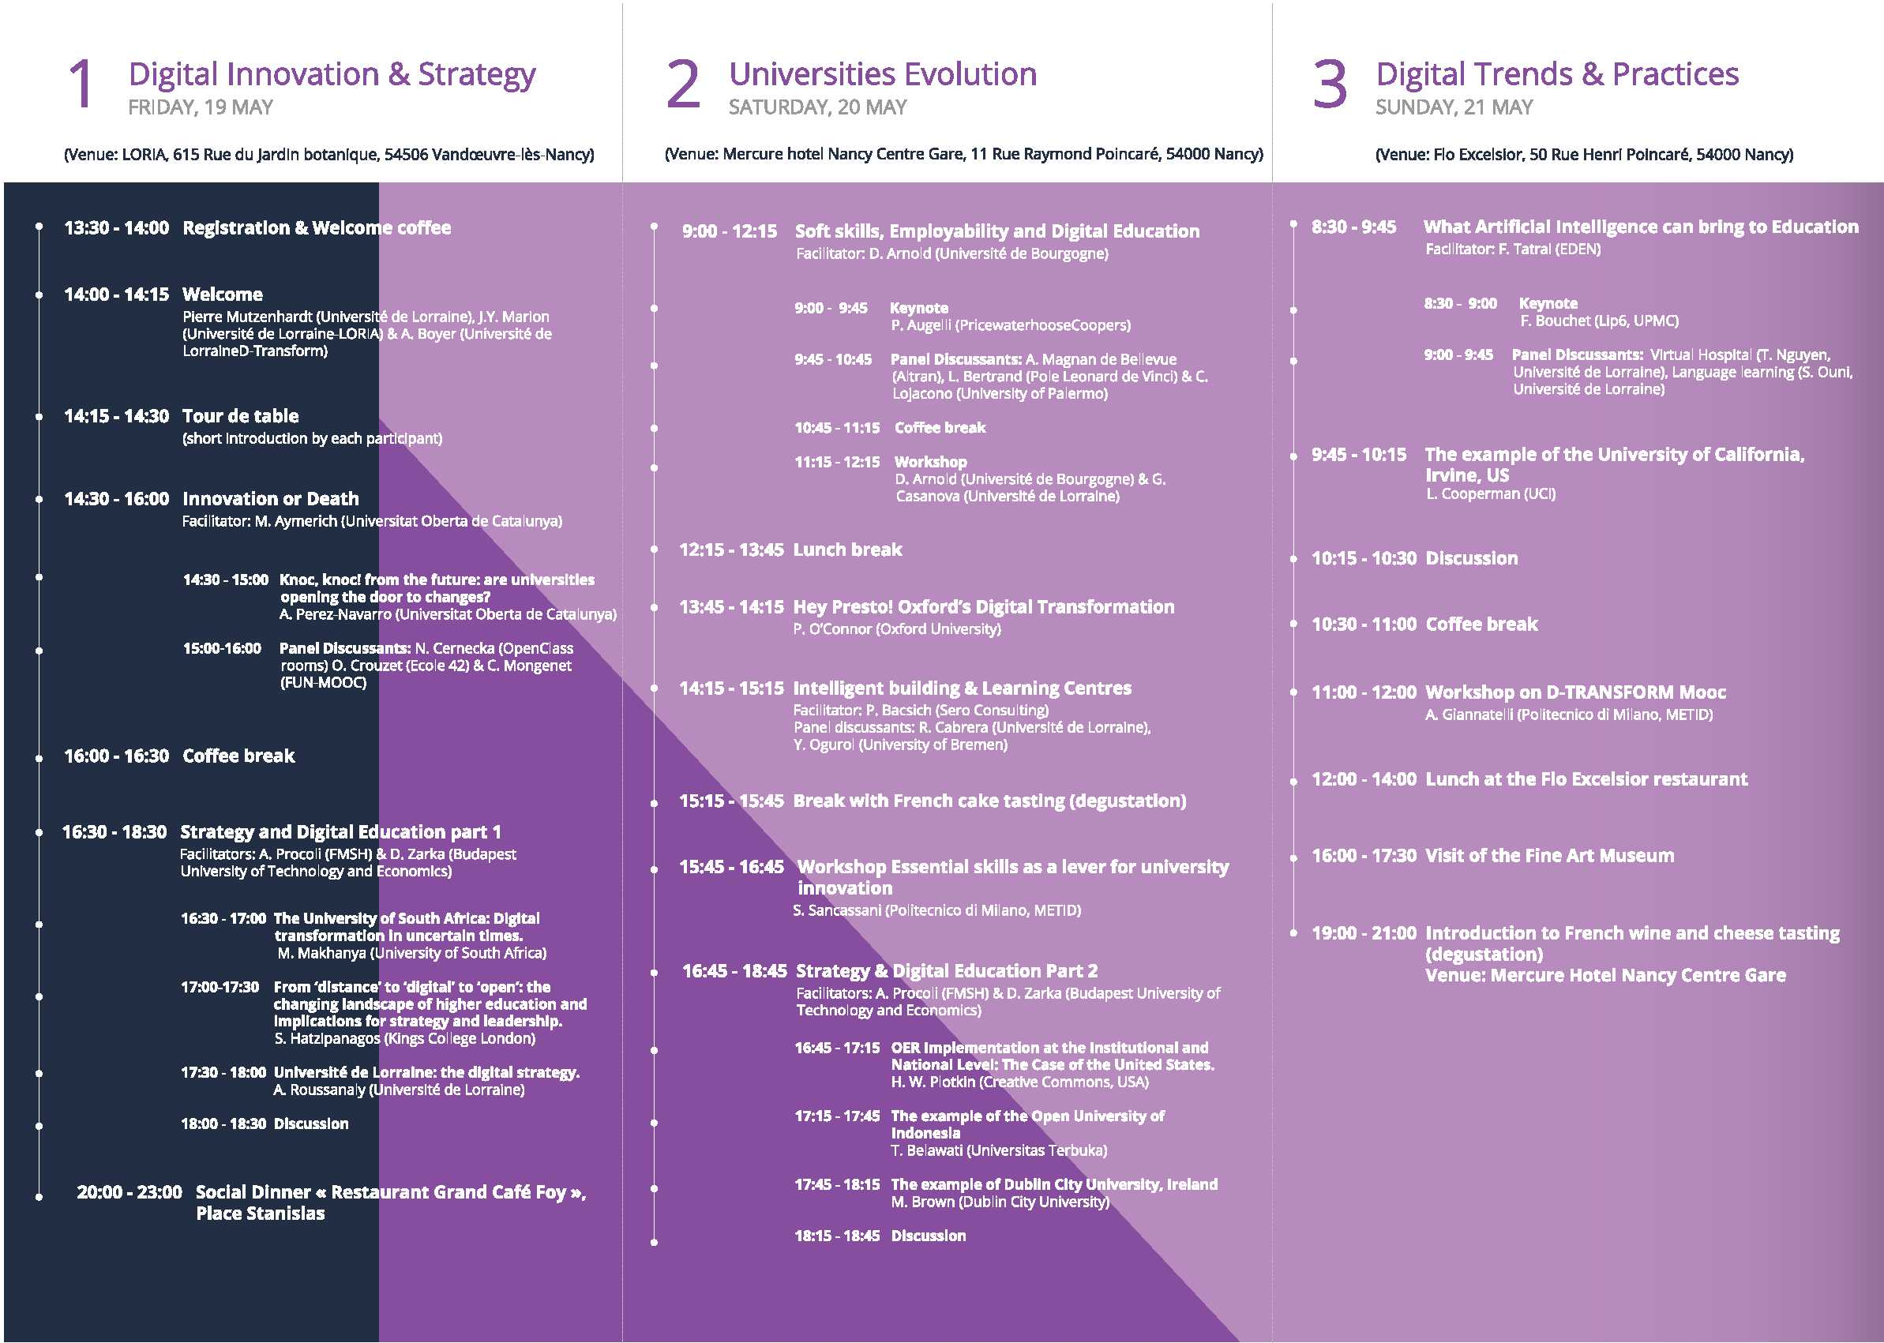
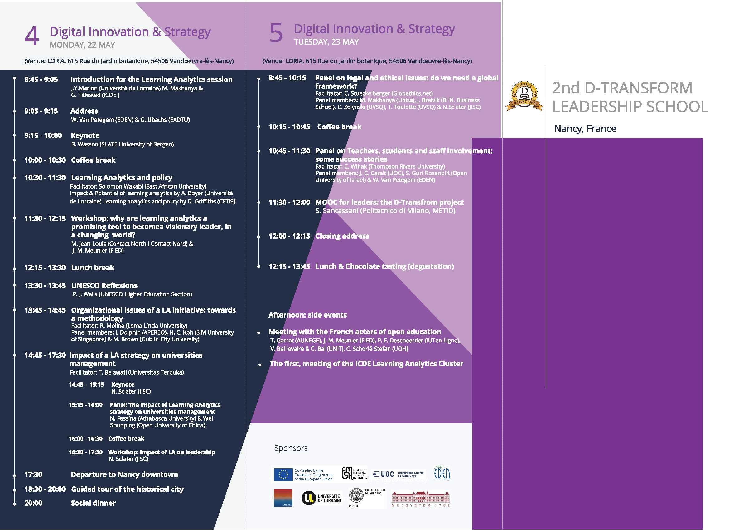

Appendix 3 – Programme of MOOC
This description is taken from https://www.pok.polimi.it/courses/course-v1:Polimi+DTransform101+2017_M5/about

Course description
With society, universities and labour market becoming more and more reliant on technology, it is important for higher education leaders to leverage the power of digital resources in order to find a strategy for change.
This MOOC is therefore aimed at raising awareness of digital resources, and especially OER and MOOCs, as a strategic factor for university transformation, with a special focus on teaching and learning processes.
In addition to that, the course promotes executive reflection on hands-on challenges and offers networking opportunities in a non-formal context.
The target audiences of the MOOC are: university rectors, vice-rectors, rector’s delegates for e-learning, rector’s delegates for university third mission, deans of faculties, directors of operational units in higher education institutions and anybody interested in the digital strategy of universities.

Course Information
The course is organised into 7 weeks; each week is devoted to a specific topic:
WEEK 1 – Universities disrupted
WEEK 2 – Models for opening up education
WEEK 3 – OER and MOOCs as innovation drivers
WEEK 4 – Academic libraries and learning spaces
WEEK 5 – Assessment and credits
WEEK 6 – Learning analytics
WEEK 7 – Overcoming academic resistance to ICT-enhanced teaching
Classes Start: May 15, 2017
Classes End: September 3, 2017
Estimated Effort: 1-2 hours/week
Language: English
The MOOC explores the new positioning of universities in the digital age along with some selected innovation fronts that entered the higher education discourse. Each week we will have a theme, and we’ll learn about it through video interviews with visionaries and practitioners from diverse organisations. You may cherry-pick the content most beneficial to you, or you may follow the suggested learning path and engage in individual or collaborative activities, sharing your thoughts with the other MOOC participants in the course forum.
Except where otherwise specified, the D-TRANSFORM MOOC is released under a Creative Commons Creative Commons Attribution-ShareAlike 4.0 International licence.

Evaluation
Quizzes aimed at assessing knowledge and understanding are not available, because they are not relevant to this discussion-based MOOC.
Upon the completion of a reflective quiz at the end of the course, you will achieve a statement of participation issued by the D-TRANSFORM consortium.
The D-TRANSFORM MOOC is not credit eligible.

Appendix 4 – Project Outputs of most relevance to Leaders
This is edited from http://www.dtransform.eu/resources/
The reports of most relevance are:
- O1-A1 Public Digital Policies in Higher Education – A comparative survey between Spain, France, Italy and the United Kingdom
- O1-A2 Business models for opening up education – Sustainability of MOOCs, OER and related online education approaches in higher education in Europe
- O1-A3 Open Educational Resource, a lever for digital transition of higher education?
- O1-A4 Guidelines for governance of HE institutions

A4.1 Public Digital Policies in Higher Education – A comparative survey between Spain, France, Italy and the United Kingdom
January 2016 by the D-TRANSFORM partnership
The project team has produced a series of surveys about digital transformation of higher education in Europe providing:
- the state-of the art on national policies
- the analysis of business models
- the implementation of Open Educational resources
The surveys are included in a final report making recommendations for university governance concerning e-learning as a lever of transformation of higher education in Europe. The 1st survey focuses on a comparative analysis of national policies for university digital transformation, implemented since the beginning of the 21st century. The main outcome of the survey is that no generalization is possible. . While all policies can be categorized within the general trends of the digital transformation, the dynamic of each higher education system puts different actors at the centre, according to the general logics of the systems. The challenge is then to produce conclusions that allow each partner country to engage in a transformation adapted to its own national context.
- DOWNLOAD the English version (pdf)
- DOWNLOAD the French version (pdf)

A4.2 Business models for opening up education – Sustainability of MOOCs, OER and related online education approaches in higher education in Europe
April 2016 by the D-TRANSFORM partnership
This D-TRANSFORM report is designed to provide guidance for senior managers in higher education institutions, mainly in four Member States of the EU – France, Italy, Spain and UK – when they come to consider whether to deploy MOOCs and related approaches, and how to justify such decisions in terms of business models and strategic relevance. There is a focus on public sector institutions, but the full range of university provision is considered, including the open universities and innovative private providers of higher education.
In order to give the work the widest possible relevance to Europe, three other European countries are looked at (Hungary, Ireland and Belgium Francophone Community) and guidelines given so that readers can research information for their countries in order to create relevant business models.
The report looks in detail at business models for US-based MOOC aggregators such as Udacity and Coursera, but with the focus on lessons that can be adapted for the European scene. This differs in several ways from the US, including on accreditation issues. It also draws insights from the range of OER, MOOC and online learning developments across Europe. The report aims to be up to date with MOOC developments until March 2016. Many interesting developments have only fully come to light in the last few months.
- DOWNLOAD the report (English version)

A4.3 Open Educational Resource, a lever for digital transition of higher education?
April 2016 by the D-TRANSFORM partnership
Easy access to educational content for the largest number is deeply rooted in our European history. The question of freely available digital open educational resources (OER) has nonetheless been a particular point of focus in the last ten years for various countries and also for international institutions, particularly in Europe. The production and diffusion of these resources have taken different aspects. They have either taken the form of “reservoirs” of educational resources whose location and access need to be facilitated, or the form of structured and rhythmic training modules comprised of classes, exercises, discussion forums, and evaluations, as is the case with on line education programs and MOOC. Whatever the form, two principles underlie this process: education for all as it is defended by UNESCO and “free”, “open”, “collaborative”, “coproduction” practices etc. carried by the web world for the sake of greater agility and global efficiency.
The media have reflected some great successes, even presenting MOOC as “the” lever for a radical transformation of educational patterns and for a better universal access to knowledge. Firm recommendations have been produced at national and international level, efforts to mutualise actions have been launched, OER are now included in the field of digital public policies (see our Public Digital Policies in Higher Education – A comparative survey between Spain, France, Italy and the United Kingdom).
Has this mobilization around OER borne fruit in terms of a wider access to knowledge for all? Facing a dual trend of commoditisation and opening up of education at world level, are OER an instrument of domination or a tool of equal opportunities and diversity? Is the trend towards sharing maximum resources or rather towards a contextualized and private usage?
Furthermore, will the development of OER lead to innovation and transformation of our educational systems linked with the digital evolution of our economy, our society and our culture? What place should it consequently be given to mobilize and educate leaders of our systems and institutions?
The objective of this report is to answer these questions, focusing on two main areas:
- the first area will concern open education confronting the ideals of this concept with reality
- the second area will question observations and perspectives in terms of evolution of higher education and the role played by OER.
In order to give context to these issues, the present report will start with a reminder of historic and geographic perspectives related to OER and MOOC before providing a general background in terms of digital governance and digital services offered to teachers and students in the institutions studied.
The report is available in English and in French.

A4.4 Guidelines for governance of HE institutions
November 2016 by the D-TRANSFORM partnership
It has already been indicated on more than one occasion, that the digital culture of governing bodies is essential for a successful digital transition in education, because these governing bodies will define and drive the transformation strategies of their establishments. In particular, information about digital trends, gathering the most promising experimentations, knowledge of future users and their typical practices, in-depth awareness of the new demands of the professional world – these are all key factors for defining a strategic vision and developing an action plan to implement that vision.
The Guidelines for governance of HE institutions, as well as the previous reports, reveals the themes that are crucial, enabling enlightened governance that is suited to today’s challenges.
Download the report here (pdf):
- ENGLISH version
- FRENCH version.

Appendix 5 D-TRANSFORM MOOC: Data snapshot
What can the first two months of delivery (15 May 2017 – 15 July 2017) tell us about the outcomes of the D-TRANSFORM MOOC?
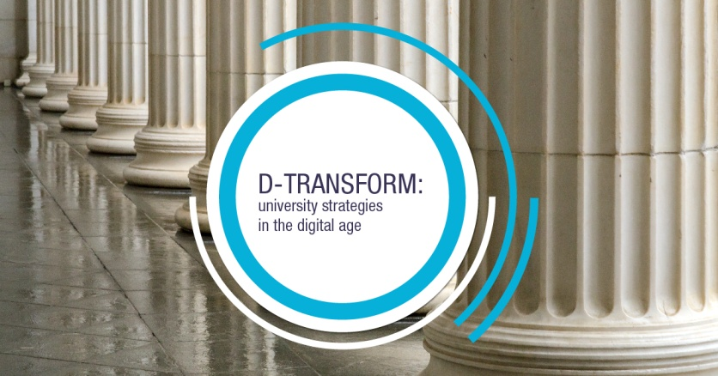 | The course is organised into 7 weeks and contains videos, infographics, resource materials, discussions in the forum, a reflective quiz.  The MOOC was launched in the context of the 2nd D-TRANSFORM Leadership School and is delivered on POK, the MOOC platform of Politecnico di Milano – Italy (https://www.pok.polimi.it/courses/course-v1:Polimi+DTransform101+2017_M5/about).

Key figures
160 | enrolled users; the course is scalable to accommodate an unlimited number of participants
19% | users that completed the final reflective quiz (aimed at obtaining the certificate of accomplishment)
737 | visualizations of the external enrolment page (“about” page), with 2 minutes average time on the page
37 | videos with about 1200 visualizations, mostly from Italy, Germany, United Kingdom and France, but also from Hungary and Spain and other countries
50 | contributions in the forum (posts, responses and comments)
30% | of participants have strategy and innovation responsibilities in higher education institutions; 54.7% of participants are 41 and over

